Assignment: Day-2 TCP/IP and Wireshark

1. Wireshark Capture (Example)
Application: HTTP GET packet
Transport: TCP segment
Internet: IPv4 packet
Network Access: Ethernet II frame.
Identified by protocol headers in Wireshark.

2. OSI vs TCP/IP
OSI | TCP/IP | Example
Application | Application | WhatsApp message
Presentation | Application | HTTPS encryption
Session | Application | Instagram login session
Transport | Transport | TCP for Zomato order
Network | Internet | IP routing
Data Link | Network Access | Wi-Fi frame
Physical | Network Access | Wi-Fi radio signals

3. TCP Header Fields
Source Port: Sender application.
Destination Port: Receiver application.
Sequence Number: Packet order.
Acknowledgment Number: Confirms received data.
Flags: Control connection.
Window Size: Flow control.
Checksum: Error detection.

4. TCP/IP Diagram
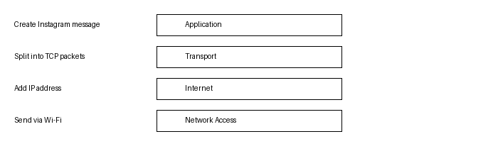

5. Example Packet
Packet: TCP SYN
Layer: Transport
Identification: TCP protocol with SYN flag.
Represents: Starting a secure connection before loading the Flipkart website or sending an app request.

